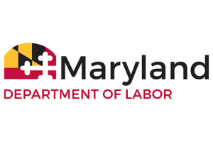
DIVISION OF LABOR AND INDUSTRY
Office of the Commissioner
1100 North Eutaw Street, room 600
Baltimore, Maryland 21201

AMUSEMENT RIDE SAFETY ADVISORY BOARD Meeting
Wednesday, June 23, 2021
10:00 a.m.
Howard Johnson Hotel
1109 Atlantic Avenue
Ocean City, MD 21842
Plaza Room
And (Virtual meeting)

AGENDA
1. Meeting Called to Order – Glenn Fishack, Sr.
2. Roll Call
3. Approval of the minutes from the November 10, 2020 board
meeting
4. Program Update – Jim Harper
5. Regulations
6. Other Business
7. Adjournment

